Linux basics
1. Creating and Renaming Files/Directories
- Create a directory named test_dir using mkdir.
- Inside test_dir, create an empty file called example.txt.
- Rename example.txt to renamed_example.txt using mv.
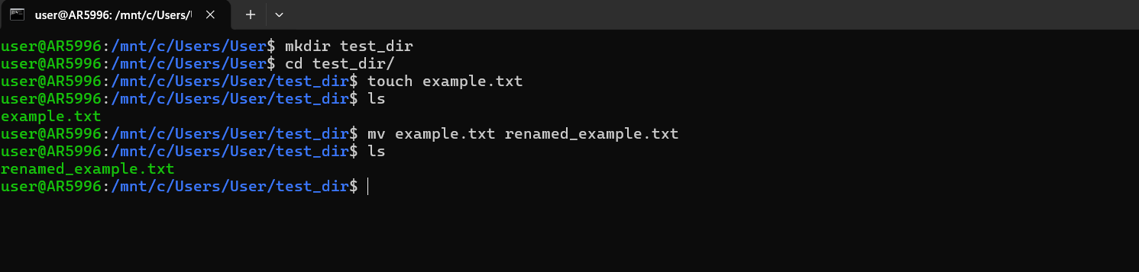

2. Viewing File Contents
- Use cat to display the contents of /etc/passwd.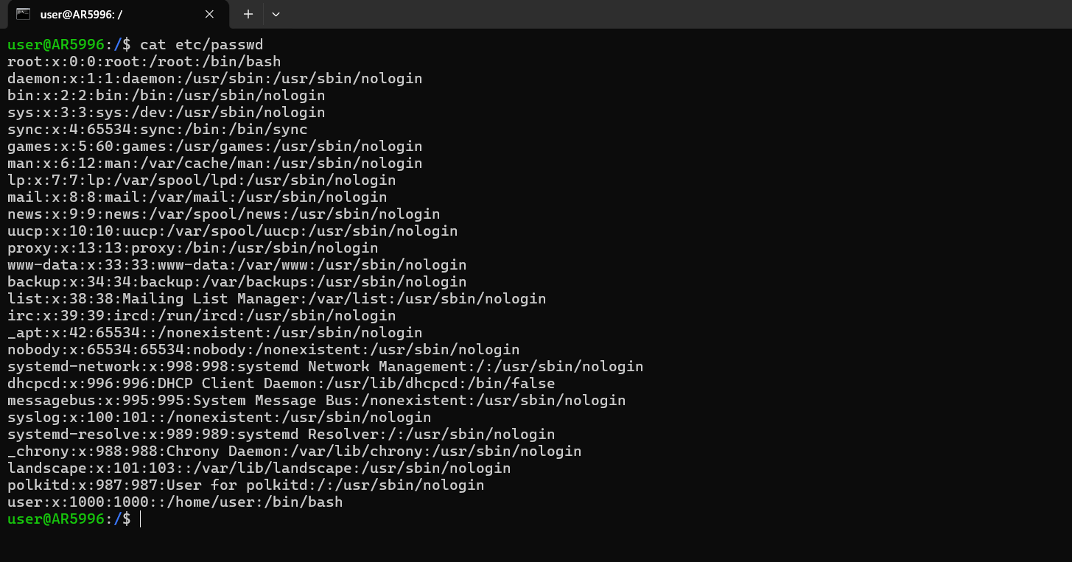
- Display only the first 5 lines of /etc/passwd using head.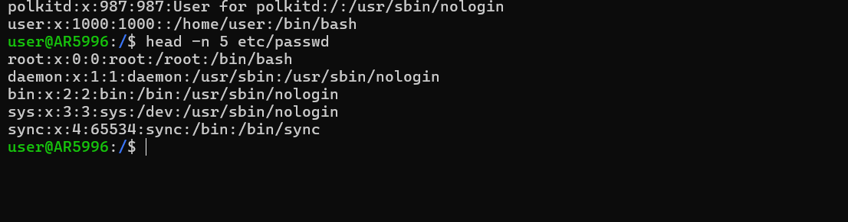
- Display only the last 5 lines of /etc/passwd using tail.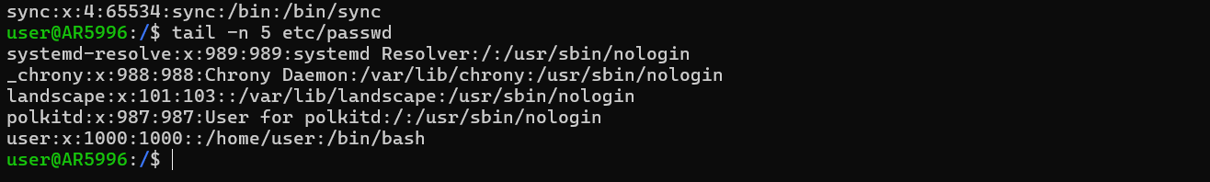

3. Searching for Patterns
- Use grep to find all lines containing the word “root” in /etc/passwd.

4. Zipping and Unzipping
- Compress the test_dir directory into a file named test_dir.zip using zip.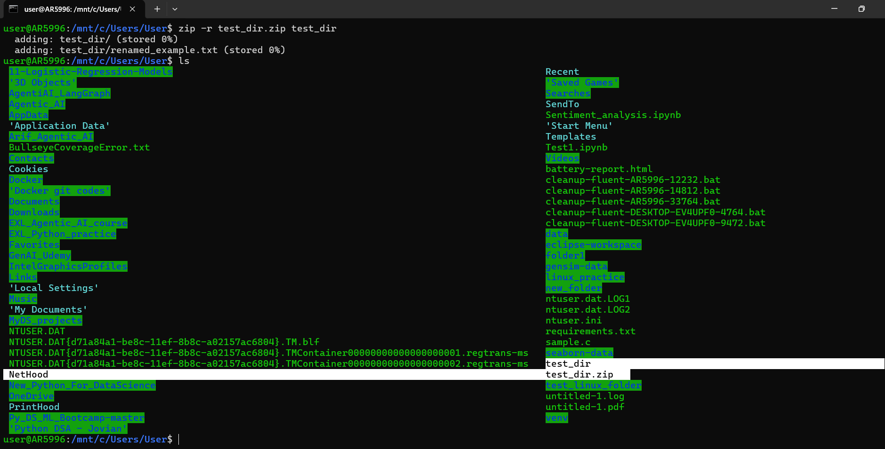
- Unzip test_dir.zip into a new directory named unzipped_dir.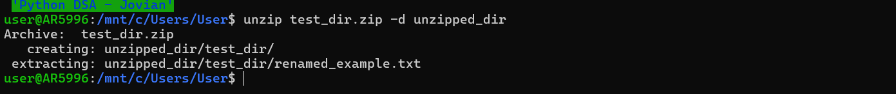

5. Downloading Files
- Use wget to download a file from a URL (e.g., https://example.com/sample.txt).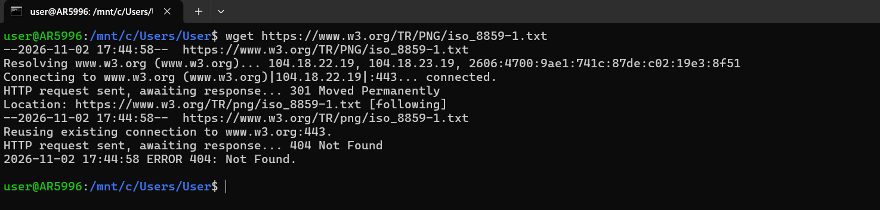

6. Changing Permissions
- Create a file named secure.txt and change its permissions to read-only for everyone using chmod.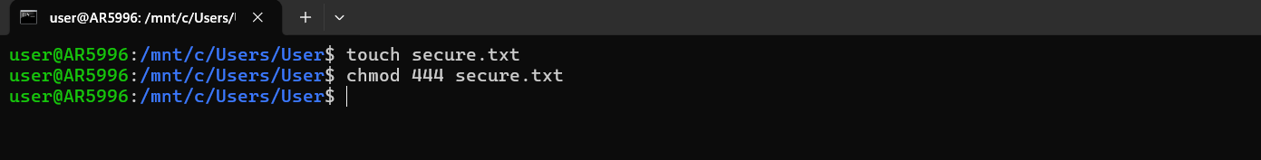

7. Working with Environment Variables
- Use export to set a new environment variable called MY_VAR with the value “Hello, Linux!”.

